**Title**: Explicit Health Benefits Package Increases Support for Universal Health Care for Subjects with High Subjective Numeracy

**Authors**: Sean Duan, BS; Victoria A. Shaffer, PhD

**Purpose**: Universal health care in the US lacks support. Explicit health benefits packages (HBPs) may improve support for UHC by heightening comprehensibility and increasing perceived equality through outlining the cost and scope of care. We compared support for UHC after exposing participants to either a HBP, uninformative control, or ‘standard’ UHC messaging from the World Health Organization (WHO).

**Method**: Study 1 (N=189) was a 2x3 mixed subjects design. Participants were randomly assigned to building their own HBP, a completed HBP, or an uninformative control. Study 2 (N= 412) was a 2x2 mixed subjects design with random assignment to either building an HBP or reading WHO pamphlets on UHC. Outcomes were measured both pre and post for both studies.

HBP building was done with the “Choosing Healthplans All Together” (CHAT) simulation exercise. Participants decide what benefit types (e.g. dental, prescriptions, tests, etc.) and what scope of coverage (basic to high) to prioritize by allocating limited resources. Support for UHC was our primary outcome measure; Perceived equality and comprehensibility were our two proposed mediating factors. Objective (Rasch Numeracy Scale) and subjective (Subjective Numeracy Scale) numeracy were moderators in Study 2. Our primary outcome, both mediators, and both moderators were measured using a 0-100 slider bar scale.

**Results**: In Study 1, both HBP interventions increased UHC support versus the control but were otherwise similar. In Study 2 there was no main effect of the intervention on support for UHC; *ps* < .05. However, there was a significant interaction between the intervention and objective numeracy. Greater objective numeracy predicted increased support for UHC in the intervention versus the control. Lastly, we found evidence of a mediational relationship for perceived equity, but not comprehensibility, on support for UHC.

**Conclusions**: HBPs increase support for UHC, but not more than ‘standard’ UHC pamphlets. We found evidence that some of this increased support from HBPs is mediated through perceived equity. There were no significant differences between building an HBP versus the much simpler process of being given a completed HBP. Lastly, our intervention had an enormously significant impact in subjects with high objective numeracy. Given how ineffective our intervention was for those with lower subjective numeracy, future research on alternative approaches more applicable to the broader population is vital.

**Word count**: 371 (375 MAX)

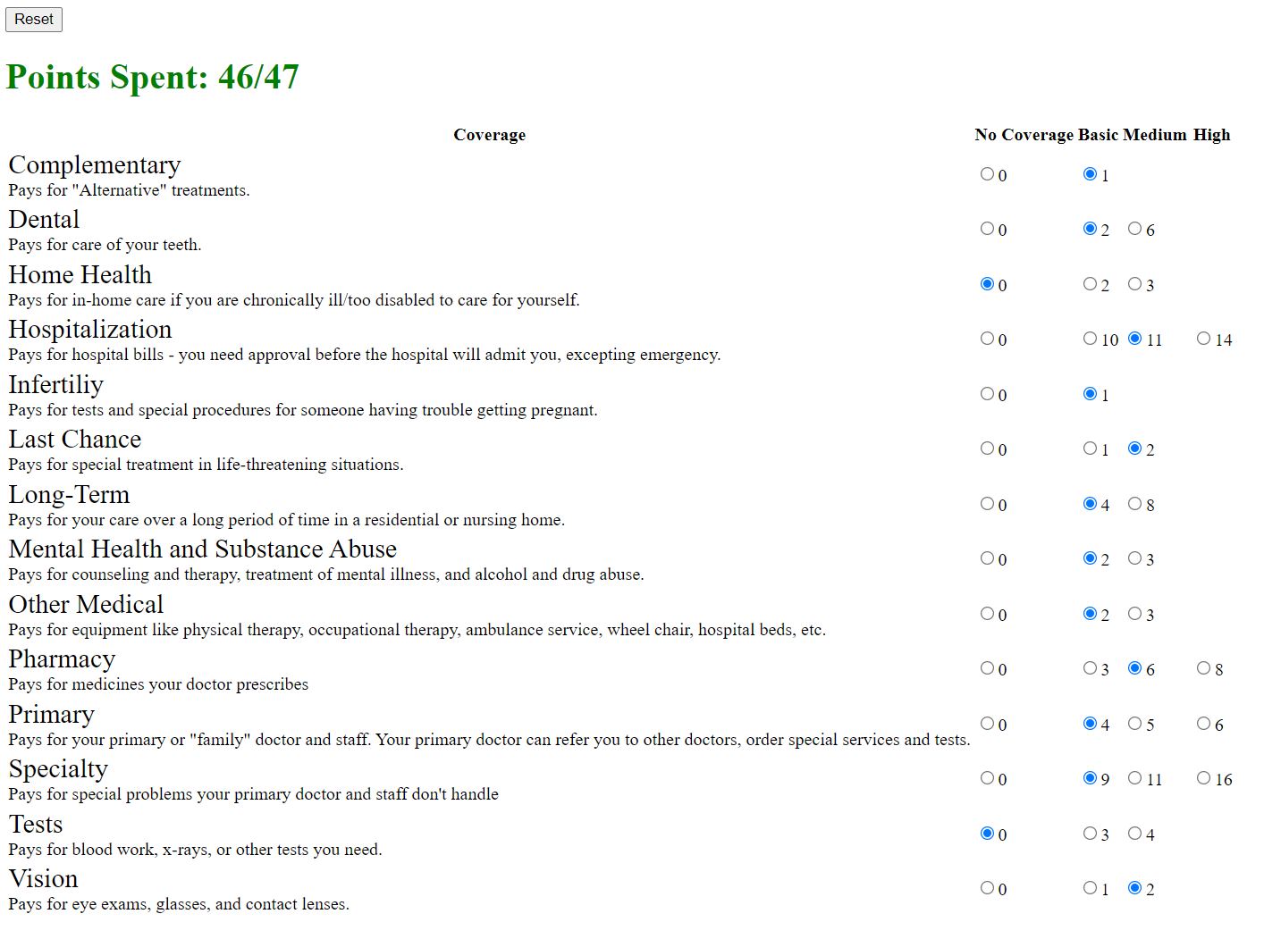Figure 1. Web application of “Choosing Healthplans All Together” exercise. 14 different categories of benefits are available at various levels of intensity. Cost in ‘points’ are chosen using buttons on the right-hand side, with the points limit shown in the upper left-hand corner.